JrLC8 YOUTH FOOTBALL LEAGUE
ROOKIE TACKLE GAME RULES
2024

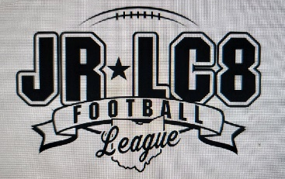

7-PLAYER RULES
Rookie Tackle uses the NFHS rule book as a base and employs the following adjustments for 7-player football:

- OFFICIALS
  - All JrLC8 Youth Football League games are to be officiated by persons who are registered by The Ohio High School Athletic Association.
  - There shall be two on-field Officials for each game
  - The on-field Officials are in charge of all on field game action.
    - Coin Flip: The coin flip can take place no earlier than 10minutes prior to start of game. This is done at the Field Officials discretion.
    - The Head Coach from each team must be present at the coin flip. At this time the Head Referee will go over any specific instructions.
  - The host site director shall provide the Field Officials an JrLC8 score card for each game to record the game date, host site, home team name, home team final score, away team name and away team final score. The score card shall be completed in full and initialed by the Head Official then submitted to the host site director at game completion. Host site directors shall report all final scores to JrLC8 and maintain scorecards for season record.

- Team Binders
  - All Head coaches are required to have on them during weigh-ins and on the sideline the approved team binder.
  - Team binder will have all up to date required and verified team paperwork.
    - Approved and signed JrLC8 roster.
    - Coaches: USA Football Coaches Cert., Concussion cert., Cardiac Arrest Cert. and Background check.
    - Players: Birth certificate, player picture and report card.
  - Any team not having their approved JrLC8 team binder will be reported to the Player Safety and Compliance officer.
  - Player Safety and Compliance officer will report to the League Commissioner for his review

- JrLC8 During Game Rule Clarification Process
  - Field Directors will assist with JrLC8 Rule clarifications.
    - The field Directors assistance of rule clarification will come from a Head Coaches request, only after the following process has been followed.
  - Steps for JrLC8 Rule clarification.
    - If the Head Coach of a team feels an JrLC8 rule is being interpreted incorrectly by the field officials the Head Coach will call a time out and request a meeting with the officials and request the host site director to assist with rule interpretation.
    - The opposing teams Head Coach and initiating head coach must be present while the discussion with the field director is taking place.
    - If it is determined that the on-field referees were enforcing/interpreting the JrLC8 rule incorrectly, the initiating team will get their time out back and moving forward during the game the rule will be enforced/interpreted as determined by host site director. If it is determined the on-field referees were enforcing/interpreting the rule correctly the initiating team will lose that time out.
    - If a team does not have any time outs left and a they feel a JrLC8 rule needs interpreted, they can at a normal stoppage of play they can request the Head Official to have the specific rule interpreted by the field director. At this time, it will be at the Head Officials discretion to allow for interpretation. If it is determined the on-field referees were enforcing/interpreting the rule correctly the initiating team will receive a 5-yard delay of game penalty.
    - At no time can this process be initiated by the Host Site Field Director.
    - Field Directors will send an email to the JrLC8 Director of Players Safety and Compliance officer detailing any game day rule clarification. The onsite field director should include:
      - What rule was clarified
      - How the referees were originally interpreting
      - How the Field Director interpreted rule.
      - Any other important information that is relevant

- PLAYERS
  - There are no restrictions on jersey numbers for Rookie Tackle.
  - There is a weight limit of 130.00 pounds for any skilled offensive position for Rookie tackle.
  - There is no weight limit for defensive positions.
  - Rookie Tackle teams shall include players from 4th and 5th grade only. Teams may not consist of only 4th graders or 5th graders.
  - Player must not reach the age of 12 prior to September 1st of the season in which he/she is participating.
  - Game day Weigh ins
    - All players will report to the designated weigh in area fifteen minutes prior to the start of the game.
    - All players must be dressed in full dress uniform. Players must be completely field ready.
    - All players must be weighed in. Only one registered coach or representative from each team will accompany their players to the weigh in area. They will confirm that proper weigh in procedure is followed.
- A player that is late for weigh-in must wait until halftime to be weighed and may not enter the game until the second half. If both coaches agree to weigh a late player in that player MUST be weighed in before the first snap of the game. Any player caught entering the game early will be considered an illegal participant.
- A player that exceeds the established weight limit must have a contrasting stripe placed on their helmet before they can leave the weigh-in area.
      - The stripe must remain on their helmet until they have weighed in again under the weight limit. This weigh-in must occur at a JrLC8 sanctioned event.
      - The contrasting strip must go from the front of the helmet to the back of the helmet.
      - The strip shall be of sufficient width and contrasting color to be immediately noticeable by the Field Officials. 2” wide duct tape or similar is ideal.

C. League Supplied Weigh in Roster
1. Must contain the following:
      - Team name
      - Date
      - A separate column for player name, number, grade level, DOB and weight (check mark in weight column if under 130.00 lbs.; actual weight if over 130.01lbs.)
      - Signature line for team representatives
    - Each program will provide all needed information to the JrLC8 by a deadline to be determined by the JrLC8.
    - JrLC8 shall provide digital and printed copies of all official league rosters to all game site Field Directors prior to the start of the season. The applicable team rosters shall be the only ones used and available for game day weigh ins by each game site Field Director.

- All game action takes place on one half of the field with all possessions starting on the 40- yard line going toward the end zone in between the numbers, the only exception to this rule is if the defense intercepts the ball between the 20yard line and the end zone the ball will then be placed on the 20 yard line to start the next possession (defense will then become offense).

- A turnover on downs brings the ball back to the 40-yard line, and the teams switch sides from offense to defense, defense to offense.

- TURNOVERS
  - Turnovers on interceptions are blown dead immediately. No returns are allowed in order to protect players from running toward the 20-yard administration zone between the two fields. Play restarts on the 40-yard line unless the defense intercepts the ball between the 20yard line and the end zone, the ball will then be placed on the 20-yard line to start the next possession with the recovering/intercepting team now on offense.
  - There are no defensive touchdowns.
  - Turnover on a fumble for Rookie Tackle is a live ball with no advancement allowed by the defense just change of possession (see yardage for ball placement above)

- After each play, the ball is spotted in the middle of the field. Hash marks are not used.

- Because of the limited field size, all 15-yard penalties are enforced as 10-yard penalties. Penalties that are normally enforced by rule as a 10-yard penalty will be enforced as 5-yards. Normal 5-yard penalties will stay enforced as 5 yards.

- No penalty on the offense can take the ball beyond the 40-yard line to ensure the administration zone.

- Penalties on the offense that are called and accepted on or behind the 40-yard line result in a loss of down.

- Penalties called on the offense between the 40-yard line and the endzone, were penalty yardage cannot be marked off in full, the defense will have the option to:
- Mark off any allowable yardage that shortened field will permit and down is played over. Or
- Decline penalty
  - EXAMPLE: 2nd down ball is spotted on 37-yard line. Offense gets called for an infraction that carries a 5-yard penalty. In this situation all 5-yards cannot be marked off because the ball would be placed beyond the 40. The defense has the above 2 options.

- There are no defensive safeties. Tackles behind the 40-yard line are re-spotted at the 40-yard line.

- All personal foul penalties include an immediate substitution from the field for a minimum of two plays to allow coaches to address misconduct and promote good sportsmanship. We call this a cooling off period.

- All plays are blown dead and the ball is returned to the 40-yard line if an offensive ball-carrier or a fumbled ball crosses over midfield or at the official's discretion if coaches, administrators or players from the multiple fields and the dead zone area become close enough in proximity to be a concern for safety.

- The game is played in four 12-minute quarters with a running clock. The clock may stop after a score to flip the field and at the change of each possession. The last minute of each half will be played as a normal game clock.

- Overtime
  - There will be no overtime during the regular season even if this results in a tie game.
  - Post season play will have overtime.
  - OVERTIME IS PERMITTED DURING THE POST SEASON. THE FOLLOWING GUIDELINES HAVE BEEN TAKEN DIRECTLY OUT OF THE OHSAA FOOTBALL MANUAL PAGE 8.
- At the end of regulation, there will be a three-minute intermission during which both teams may confer with their coaches. During the intermission, the officials will meet the captains at the center of the field for a coin toss. The winner of the toss shall be given the choice of defense or offense or which end of the field the ball will be put into play. Each team will be permitted one timeout per overtime period.
- After the coin toss, the offensive team will put the ball in play, first and 10 on the defensive team’s 20-yard line. The possession shall be terminated if the offense scores, the defense has possession of the ball at the end of any down (if the defensive team gains possession, the ball becomes dead immediately) or the offense fails to make the line-to-gain.
- After the offense has completed its possession, the defense will become the offensive team. In order to ensure equal game conditions, the same goal shall be used by both teams.
- If the score remains tied after each team has been given one series, the procedure shall be repeated, except there will be no coin toss, until a winner is determined. There will be an intermission of two minutes, during which the loser of the original coin toss will be given first choice of the options, which includes the option to change goals. First choice of options will alternate for each overtime period.

- BALL SIZE
- Rookie Tackle will use Junior size ball.
- Organizations may choose the manufacturer of their choice; however the ball cannot match your teams the jersey color.

- One coach per team will be allowed on the field during game play
  - The on-field coach must be a minimum of 5 yards behind the deepest player on their side of the ball.
  - The on-field coach will not physically assist a player attempting to make a play on the field. This will be flagged as unsportsmanlike conduct and result in a 10-yard penalty.
  - If the referee deems interference to be unintentional, the unintentional coach interference will be treated the same as if it was unintentional Officials interference.

- First downs Rule
  - Upon the start of a possession or after a first down the offensive team will have 4 plays to gain 15 yards. Unless it is inside the 15-yard line in which it will be first and goal.
  - If the defense intercepts the ball between the 20 yard line and the end zone they have 4 plays to reach the goal. Intercepting team takes over possession 1st and goal on the 20.

- Point After Attempt
  - After a touchdown has been scored the on-field coach or Head Coach will advise the official of what yard line they will attempt the PAT from:
- 3-yard line: 1 point
- 5-yard line: 2 points

- There are no field goal attempts.

- There are no two-point defensive safeties. All tackles behind the 40-yard line result in a loss of down, but the offense retains the ball, and the ball is re-spotted at the 40-yard line to preserve the administrative zone.

- Special team's adjustments
  - There are no special teams.
  - There are no kickoff or punts. Each possession starts with the ball on the 40-yard line, regardless of whether there is a score or turnover on downs. The only time the ball does not start on the 40 is when the defense intercepts between the 20 and the goal line. The ball then is placed on the 20-yard line

- Offensive adjustments
  - Each play must include three offensive linemen - a center and two guards, one on either side of the center. The Center and Guards are not allowed to advance the ball. These players are ineligible for first touch as the receiver of a pass regardless of the numbers on their jerseys. Player rotations may result with traditional non-lineman numbers at these positions for the purpose of fundamental skill development.

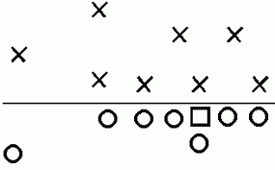

  - Guards must play from a two-point stance
  - The center may only have his or her snapping hand down.
    - The only player allowed to be in a 3-point stance is the center, all other players on the LOS must be in a 2-point stance.
  - The distance between a guard and center may not exceed three feet (1 yard) but may be closer.
  - Because of the all players, all positions, all skills philosophy, players should change positions during the game. Therefore:
    - Offensive lineman may not shift to another position.
    - All three offensive linemen are ineligible for first touch on a pass, including a guard who is uncovered by an end.
  - The quarterback-center exchange may be direct, pistol or shotgun.
  - Quarterback sneaks from under center are prohibited in all situations because the defense is not allowed to have players aligned over the center or in the center-guard A gap. The Quarterback may rush through the A gap from a shotgun snap or after a drop back pass attempt from under center.
  - The offense must have four players on the line of scrimmage. No more, no less. The fourth player can be a tight end or split end. See figures below.
  - The four offensive players who are not playing guard or center may be deployed in positions at the coach's discretion as long as one is on the line of scrimmage (see rule 9).

The 4th player can be a tight end or Wide out

  - No trips formations are allowed.
    - Trips is defined as any three players outside the guard to-guard box.
ILLEGAL

LEGAL

  - Motion is allowed by a backfield player considering it does not create a trips formation.
  - All blocks below the waist, in any situation, are illegal.

- Defensive Adjustments
  - Defenses must have two defensive linemen unless an offensive formation includes a tight end. In that case, a third defensive lineman may line up over the tight end.
  - Defensive linemen must be in a two-point stance.
  - Defensive linemen over guards must be aligned in a head up position, guards must be covered.
  - The defense must have one player at least 10 yards from the ball.
X

X X
  - The remaining four players can be deployed at the coach's discretion but must be 4 yards off the line of scrimmage unless covering a tight end or split end on the line of scrimmage.
    - Example: If the offense aligns with its fourth line-of-scrimmage player as a tight end, then the defense may align a player directly over the tight end on the line of scrimmage to balance the running surface.

X X X
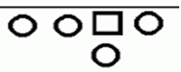
    - Defenses are not required to match the fourth player on the line of scrimmage but have the option to do so.

  - No blitzEs are allowed
    - The box includes offensive players (guard to guard) who line up within two yards of the ball and on the line of scrimmage along with the defensive guards lined up directly over the offensive guards.
X X

    - Defensive guards within the box at the snap can penetrate the B-gap (outside the offensive guards) or drive directly through the offensive guard upon the snap. No A-gap blitzing (penetration upon the snap) from defensive guards.
    - Linebackers, safeties and cornerbacks (both on the line and at depth) can flow to the ball naturally after a handoff is made or after a running QB exits the guard-to-guard offensive box but predetermining penetration to a specific gap is illegal.
    - On pass plays, anyone outside the box on the snap cannot rush the quarterback and must remain behind the line of scrimmage in pass coverage.
    - Coaches are encouraged to be creative with their formations but not use "the box" to delay defensive penetration.
      - NOTE: The restriction on blitzing is intended to encourage skill development within the passing game and to allow young players to execute a successful handoff with limited penetration.
    - Predetermined blitzing by the defense. 5-yard penalty
  - If the ball is inside the 4-yard line, the four non-linemen, non-deep players may align on the goal line.

- FIELD LAYOUT:
  - Field layout does not have to have spilt fields. You can run one game; however, you must follow game play/flow.

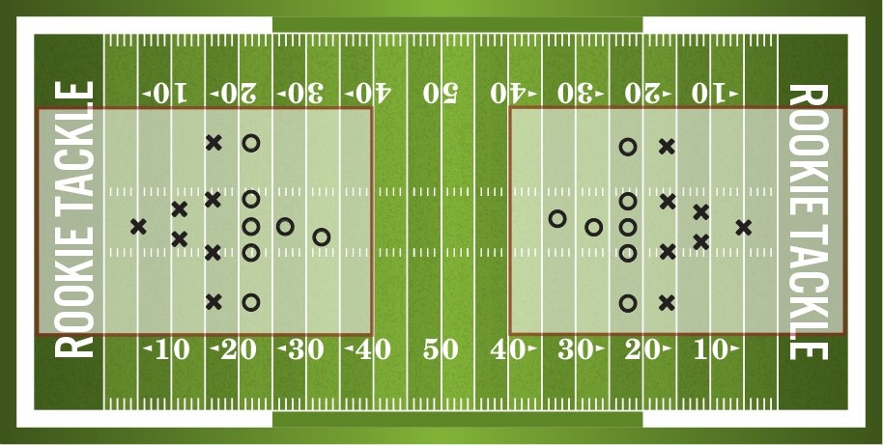
(Note this image shows Rookie Tackle though same field dimensions apply also to JrLC8 Flag and Padded Flag)

  - The playing field is 40-by-35 1/3 yards, allowing for two fields to be created on a traditional 100-yard field at the same time.

28. SIDELINES
A. NO PARENTS OR SPECTATORS SHOULD INTERFERE WITH THE TEAM ON THE SIDELINE.
B. IF BOTH TEAMS ARE LOCATED ON THE SAME SIDE OF THE FIELD THEIR TEAM AREAS ARE THE 40-20 YARD LINE & 20YARD-GOAL LINE. IF TEAMS ARE ON OPPOSITE SIDES OF THE FIELD A THEIR SIDELINE AREA IS FROM THE FORTY (40) YARD LINE TO THE TWENTY (20) YARD LINE. NO EXCEPTIONS. IF COACHES OR PLAYERS CROSSOVER THEIR TEAM AREA RESTRICTIONS THE TEAM WILL RECEIVE ONE WARNING. ADDITIONAL VIOLATIONS WILL RESULT IN A FIVE YARD PENALTY.
C. IF THERE IS NO FENCE PRESENT AROUND THE FIELD THE HOST SITE IS REQUIRED TO CREATE A 7 YARD BUFFER USING CONES OR SIMILAR MARKERS TO CREATE SPACE BETWEEN THE PLAYING FIELD AND SPECTATORS

